The Crude free fall

By Teddy Dubno

HSA10-05 The Economics of Oil and Energy

March 7, 2016

**Background:**

Crude oil has been one of the most important if not the most important resource globally for decades. Crude oil has many uses and is used in virtually every aspect of the modern world. Due to the prevalence of refinement and constantly growing demand of oil production has risen to meet it. Oil is a very essential commodity due to its many uses. The refinement process gives many of the resources that the world uses every day. The primary use of the refined crude oil is fro transportation with nearly ¾ of the total oil conception being used for transportation alone[1]. Nearly 35% of the total energy consumption in the United States comes from the use of petroleum and the products of the refinement process of Crude oil1 The trend of oil price and the ability of oil producers to satisfy demand have been relatively consistent for years. However recently there has been a steep decline in Crude Oil price per barrel caused by a rapid increased production. There are many potential causes of the decline in oil prices. There have been attempts to quell the fall and appose the increase of production however certain producers have fueled this increased production and led to the current situation.

**Overview of Oil price trends:**

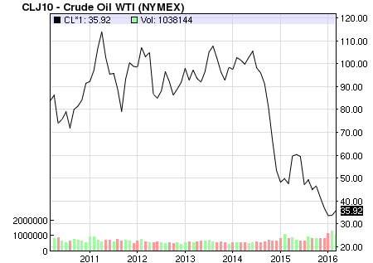The Price of oil has been relatively steady over the past 6 years[2], however at 2015 the price of oil suddenly fell and the price of oil has yet to recover. As visible on this graph the rapid decline of Oil price starting at the end of 2014 all the way into 2016.

**Causes:**

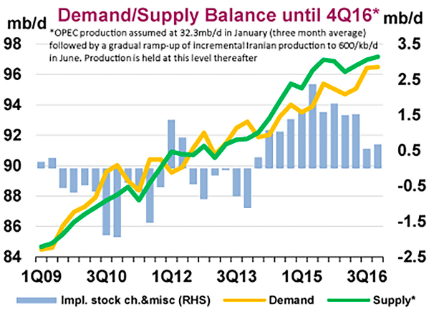There are many potential causes of the rapid decline of oil prices. The most globally accepted is the drastic increase in production and the surplus oil produced. As visible in the figure below the imbalances between supply, and demand. [3]

The many spikes in production and the subsequent drop in price per barrel of crude oil coincide with the initial discovery of hydraulic fracturing and horizontal drilling techniques4. Fracking has enabled the United States to nearly double Oil production in less than six years. This increased production has led the united stats to import dramatically less Crude oil. The United States imports 2,811,000 Fewer barrels of oil per day than it did less than six years ago before fracking was as well developed and employed.[4] This dramatic decrease in imports combined with ramped up production has led the price of oil and subsequent prices of it derivative materials (gasoline, petroleum, etc.) to be greatly reduced.[5] The ramped up production has had other effects on global Crude oil production due to the global trade status of the commodity.

Macintosh HD:Users:TeddyDubno:Downloads:chart.pdfOne of the most significant effects of the United States’ ramped up production as a result of fracking is the forced competition it has instilled in many of the Nations in OPEC (The Organization of the Petroleum Exporting Countries[6])[7]. Due to the increased production and subsequent dramatic increase in oil and oil derivative exports by the United States[8], OPEC has had to raise production to offer competitive pricing on their exports. Countries like Saudi Arabia, the largest producer and semi leader of OPEC8, have the majority of their wealth coming from their oil exports. In order to stay in the “race” and keep at a competitive position relative to the United States OPEC has had to increase production way beyond what is necessary to meet global demand. This multi sources increase of production has cause the price of crude oil to plummet rapidly and has prevented it from stabilizing. These oil producing powers have created a viscous cycle where production has to be increased to stay competitive yet prices are lowering so more needs to be produced and exported to make money, and thus the price falls again and so on.

While this line of thinking is generally believed to be the source of the current economic situation there are those that believe the increased production by OPEC, most notably Saudi Arabia is due to their desire eliminate some production competition[9].

**General Effects:**

The effect of the steep decline of oil prices is varied from country to country but has great consequences on the global economy. One of the nations hit hardest by the sudden drop in oil prices is Russia[10]. Russia’s economy is in the toilet so to speak because they are trapped between a rock and a hard place when it comes to oil production and export. Crude oil accounts for near seventy percent of Russian export income. Russia is unable to support its economy to the same 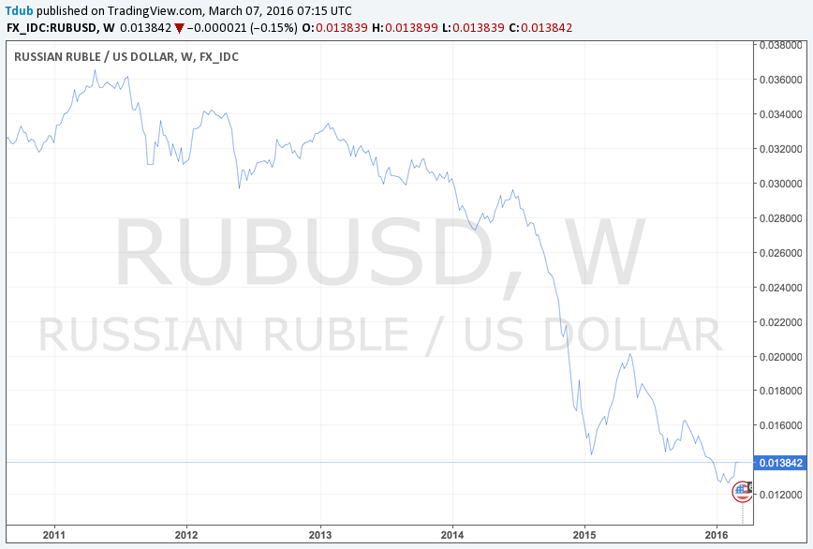standard, as it was when the price of oil was higher. Russia loses about two billion dollars in revenue for each dollar the price of Crude oil falls by. In response to this unexpected decline of oil price the ruble, Russia’s currency, has plummeted in value and the Russian economy has felt the strain due to the Russian government budgeting for a much higher price per barrel of crude oil9.

Venezuela, a leading oil producing nation has also felt the sting of low oil prices. The effect of cheap oil has led a country where the oil is one of the main sources of political and economic power, into a state of instability[11]. This nation, which under the very high oil prices of the past, was able to use it healthy oil preserves to fund its economy and prop up its government, is now facing many problems as a result of the falling oil price. Approximately 25 percent of Venezuela’s GDP(gross domestic product) is from the sale and exportation of Oil. However, now, due to the drop in oil price the country is in a state of disrepair with inflation rising somewhere in the neighborhood of 270%[12]. This drastic change of oil prices and the general effect that it has on many oil producing nations highlights the fragility of the situation and demonstrates the sever dependence on crude oil.

There are other more wide spread effect of the change in oil price. Globally oil producers have had to make sure that their oil extraction methods can remain profitable with the price per barrel falling steadily[13]. This may be a potential cause for the rapid increase of production by certain OPEC nations. Many of the more expensive methods of production, and many countries, like Canada, are discovering that the cost per barrel is approaching, and even occasionally falling under, the cost of production per barrel10. While some methods of production like shale fracking are coming close to the breakeven point there is still a need to produce to avoid a net loss10. While this may be a widespread concern in the oil producing community, there are still those oil producers who can continue to make some profit indefinitely as the prices fall. Saudi Arabia for example can continue to produce crude oil at far lower prices than most countries[14]. Some estimates put the price of production at around $9.90 per barrel[15]; this is a lot less than the estimated $25 dollar per barrel estimated for the united state shale price per barrel[16]. The effect of this is that by increasing production Saudi Arabia is able to force shale into becoming unprofitable.

If this trend is able to continue and production does not stop than there is a very real possibility that United states oil production will have to operate at a net loss which could cause the companies to go out of business allowing OPEC and other large scale oil producers to gain a larger market share and get a greater control over the global supply of oil. This could be even more drastic than the current situation as the price of oil could be mainly controlled by a single Crude oil cartel.

**Conclusion:**

The dramatic increase in the production of Crude oil has led to an dramatic decrease in the price per barrel of crude oil. This price drop has deep and real consequences for many nations and companies where their main revenue source is the sale and exportation of crude oil. There are many potential causes to this ramped up production, whether it is an increase in petroleum extraction technology or a well designed plan to gain a controlling share of the market, there will be long lasting economic-political consequences that will dramatically shape the global economy in the future. The global dependence on oil and the severe degree that fluctuations affect the world economy indicate a need for restructuring and increased stability.

1. https://www.eia.gov/energyexplained/index.cfm?page=oil_use
2. http://www.nasdaq.com/markets/crude-oil.aspx?timeframe=6y
3. <http://www.vox.com/2016/1/12/10755754/crude-oil-prices-falling>
4. <https://www.eia.gov/dnav/pet/pet_move_impcus_a2_nus_epc0_im0_mbblpd_m.htm>
5. https://www.eia.gov/dnav/pet/pet_pri_gnd_dcus_nus_w.htm
6. www.**opec**.org
7. <http://www.vox.com/2016/1/12/10755754/crude-oil-prices-falling>
8. https://www.eia.gov/dnav/pet/pet_move_exp_dc_NUS-Z00_mbblpd_m.htm
9. http://marketrealist.com/2016/01/crude-oils-total-cost-production-impacts-major-oil-producers/
10. http://www.bbc.com/news/business-29643612
11. http://www.investopedia.com/ask/answers/032515/how-does-price-oil-affect-venezuelas-economy.asp
12. http://www.aljazeera.com/news/2016/01/venezuela-economic-crisis-worsens-oil-prices-fall-160108105010345.html
13. http://www.investopedia.com/articles/investing/072215/can-fracking-survive-60-barrel.asp
14. http://marketrealist.com/2016/01/war-words-opec-nations-crude-oil-market/
15. http://marketrealist.com/2016/01/crude-oils-total-cost-production-impacts-major-oil-producers/
16. http://marketrealist.com/2016/01/crude-oil-price-forecasts-suggest-pain-oil-prices/